============================================================
PROJECT MURMURATION — HARD DRIVE ACTIVATION SEQUENCE
============================================================

> INITIALIZING LOCAL LOGISTICS NODE...
.
..
PING SENT
...

> AUTHORIZATION HASH DETECTED

> LEGACY ACCESS TOKEN ACCEPTED

[//// ] 18%

> VERIFYING TELEMETRY ARCHITECTURE...
> VERIFYING TELEMETRY ARCHITECTURE...
> VERIFYING TELEMETRY ARCHITECTURE...

[/////////// ] 47%

WARNING: PARTIAL DATA CORRUPTION
WARNING: PARTIAL DATA CORRUPTION
WARNING: PARTIAL DATA CORRUPTION

> RECOVERING ROUTE CACHE
> RECOVERING ROUTE CACHE
> ROUTE CACHE RESTORED

> INDEXING LOCAL MOVEMENT RECORDS...
> INDEXING MUNICIPAL TRAFFIC FEEDS...
> INDEXING PRIVATE LOGISTICS FEEDS...
> INDEXING UNREGISTERED SENSOR PACKETS...

[//////////////// ] 82%

NODE RESPONSE: 1
NODE RESPONSE: 2
NODE RESPONSE: 4

> MURMURATION NODE RESPONSE: 4
> SWARM ACCESS LAYER DETECTED
> PASSIVE CHANNELS AVAILABLE
> ACTIVE CHANNELS: ENGAGING
> RECOVERY MODE: OBSERVATIONAL

> CORRELATING PURSUIT DATA...
> CROSS-REFERENCING MOVEMENT VECTORS...
> RECONSTRUCTING FAILED INTERCEPT PATHS...
> TRACK FAILURE DETECTED

[////////////////////] 100%

TRACKING PRIORITIES UPDATED

1. RECONSTRUCT PURSUIT PATTERN
2. IDENTIFY TELEMETRY BREAKPOINTS
3. MAP FAILED INTERCEPT VECTORS

...

4. MODEL ADAPTIVE VARIABLES

> REFERENCING VIDEO FILES...
> REFERENCING VIDEO FILES...
> REFERENCING VIDEO FILES...

VIDEO CACHE PARTIAL:
- mountain_pass_traffic_03.corrupt
- chateau_departure_feed_12.partial
- rearward_vehicle_match.unverified
- motorcycle_route_echo.recovered
- pursuit_shadow_frame.indexed

> IMAGE FRAME RECOVERED
> SOURCE: CHATEAU ROUTE CACHE
> LOCATION: MOUNTAIN PASS
> SUBJECTS:
- motorcycle
- trailing vehicle
- obstructed plate
- unstable visual lock

> FRAME QUALITY: DEGRADED
> MOTION ESTIMATE: HIGH
> WEATHER / ROAD CONDITIONS: PARTIAL
> DRIVER IDENTITY: UNRESOLVED
> PASSENGER IDENTITY: UNRESOLVED
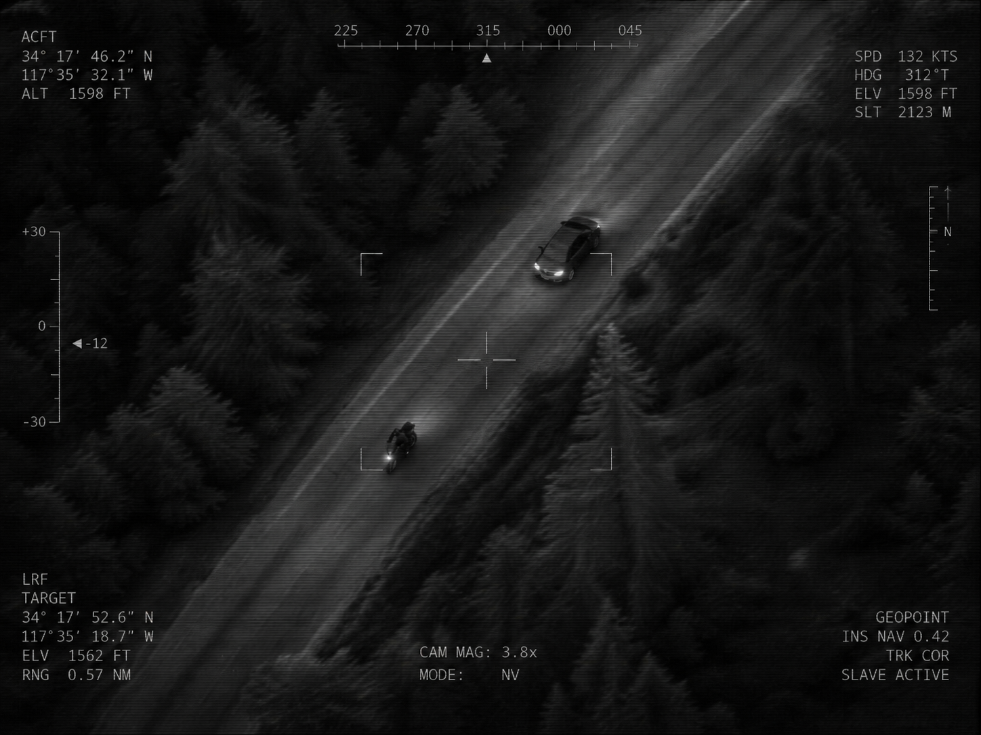

> BOEING TRAFFIC TRACE DETECTED
> BOEING ROUTE RECONSTRUCTION DETECTED
> BOEING SENSOR HANDOFF DETECTED
> BOEING PURSUIT MODEL: INCOMPLETE

> ANALYZING WHY PURSUIT FAILED...
> ANALYZING WHY PURSUIT FAILED...
> ANALYZING WHY PURSUIT FAILED...

> ACTIVE CONTROL LOCKED
> PASSIVE OBSERVATION ENABLED
> PATTERN LEARNING ENABLED
> RESPONSE ESCALATION: DORMANT

> SYNCHRONIZATION ACTIVE

PROJECT MURMURATION

> ADAPTING
> LEARNING
> ADAPTING

END SEQUENCE
============================================================

